How to enroll in classes with

- Go to https://ar.flvs.net

- Click this button to start creating your
Account

- Click on Florida Icon, then pick Osceola County & Public/Charter School Student from the drop down menu
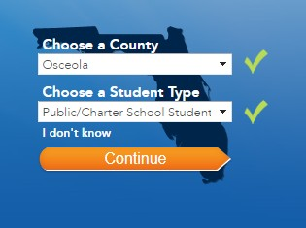

- Select Subjects on left
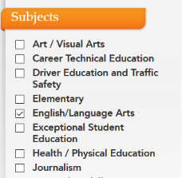

- Choose your course

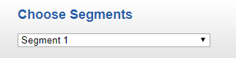
- Choose your segments (1 for 1st semester, 2 for 2nd semester, All for all semesters)

& check acknowledgement box

- Choose your start date
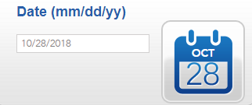

- Choose Osceola Virtual School
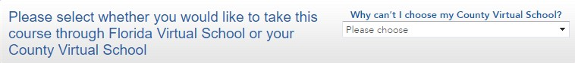

- Click Continue.

- Complete the questionnaire
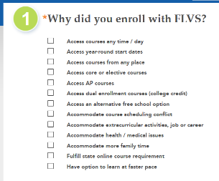

- Review backpack, click continue or add classes

- Click Create My Account

Counselor Suggestions:
We recommend using your Osceola school email address.
Course: ________________________
Segment(s): ______________
Start Date: __________________

WELCOME TO OSCEOLA VIRTUAL SCHOOL (OVS)
Welcome Calls
- Students must complete a Welcome Call within the first 7 calendar days of being assigned to a class (CA).
- Students can access the Welcome Call PowerPoints through their teacher’s Welcome Page. The Welcome Call PowerPoint must be viewed with your parent and the assignment must be submitted prior to being Activated (A).
- Students may also schedule a Welcome Call over the phone, if they wish. Student would be responsible for contacting the teacher to schedule a date and time.
Pacing
- Students should maintain a pace of 6% each week in each course once they have been activated. Half credit courses are designed to be completed in 18 weeks.
- Students must be on track within the first 14 calendar days or risk being removed.
- Students who do not log in for more than 10 calendar days in a row may be withdrawn from the course.
Discussion Based Assessments (DBA)
- Students are responsible for scheduling the DBA’s with teachers for each module. Students can either make an appointment with the teacher for a phone DBA or attend one of the live sessions through ZOOM. Please check your teacher’s Welcome page for their available DBA times.
- Students must successfully complete their DBA to continue through the course.
- Failure to attend a scheduled DBA’s will jeopardize enrollment.
Academic Integrity
- Students are expected to complete their own schoolwork. It is unlawful to copy from the internet or have work completed by anyone else other than the student to whom the course is assigned. FS.775.082 or FS.775.083
- Students who commit academic integrity may be dismissed from Osceola Virtual School.

